Movers Profile Errors
Sub movers par iss tar add kar da
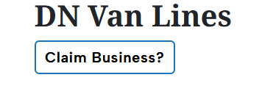

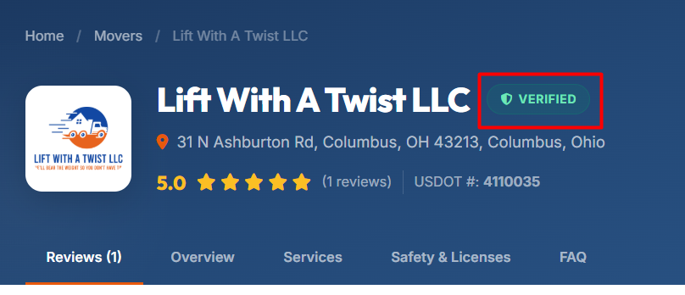

Is ko set kar do
Get a Free Estimate is ko H3 Kr dana
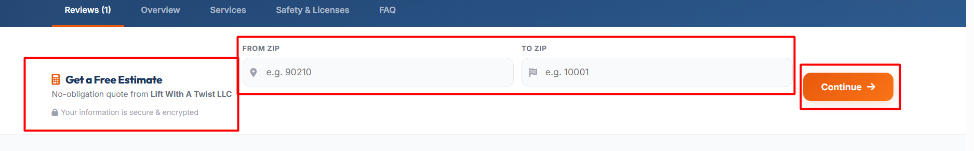
Is par sa bhi heading tag remove kar do
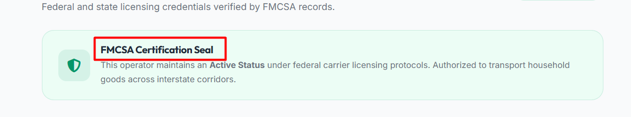

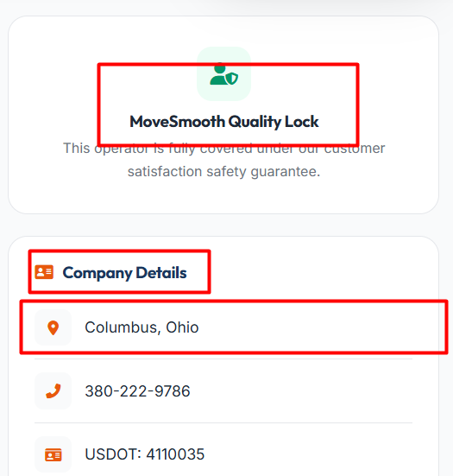
Move smoth ma space do
Company details par H3 kar do
Address Full add karo

Recommended 7 FAQs Add in page or schema
1. Is [Company Name] a licensed moving company?
[Company Name] should maintain the required licenses and operating authority for the services it provides. Customers should verify the company's current licensing and insurance information before booking a move.

2. What moving services does [Company Name] offer?
[Company Name] may offer local moving, long-distance moving, residential moving, commercial moving, packing, unpacking, and storage services. Contact the company directly to confirm the services available for your move.

3. How much does [Company Name] charge?
Moving costs vary based on factors such as distance, home size, moving date, and additional services. Request a free moving quote for pricing tailored to your move.

4. Are the reviews for [Company Name] verified?
The reviews displayed on our website go through our review verification process to improve accuracy and help customers make informed moving decisions.

5. Does [Company Name] provide storage solutions?
Storage options may vary depending on the company's services. Contact [Company Name] to check the availability of short-term or long-term storage.

6. Is moving insurance available?
Most moving companies offer basic valuation coverage, and some may provide additional protection options. Ask [Company Name] about the coverage available for your move.

7. How can I request a quote from [Company Name]?
You can request a free moving quote by contacting the company directly or by using the quote request form on our website. Providing accurate move details helps you receive a more accurate estimate.
In par sa Heading tags remove kar do par ya show ho asa hi ok
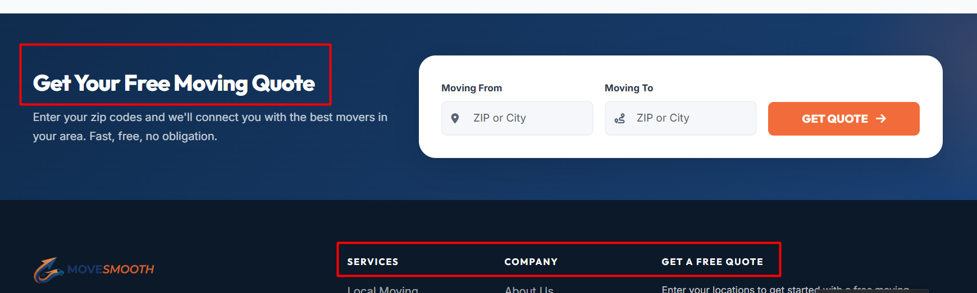

Ya page nhi ha in ko remove kar do
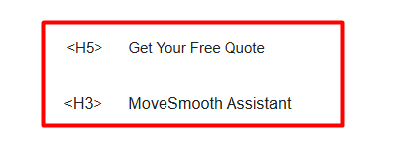
Is ko fix kar do
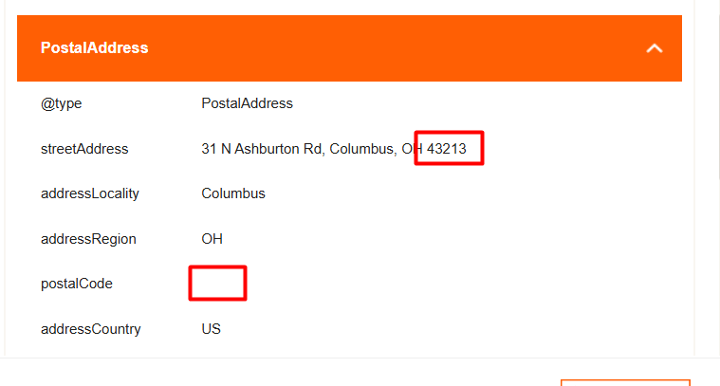
Is ko dehk ka shi kar da
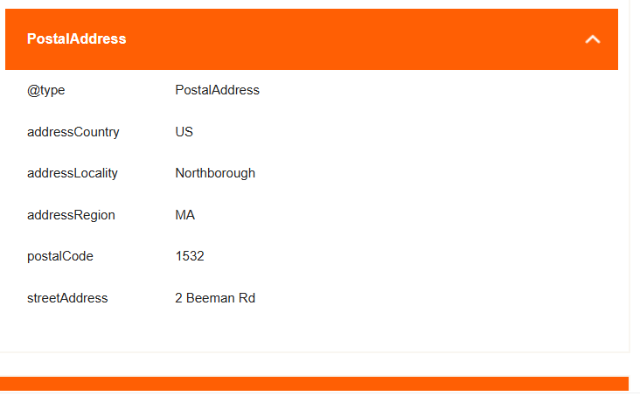

Ya bhi add kar do
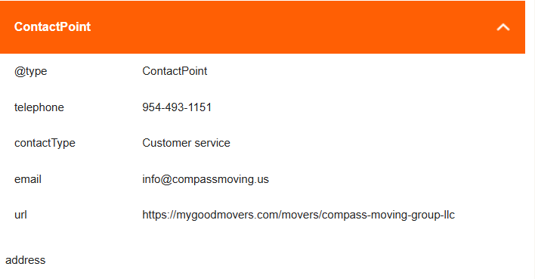
Author name bhi add karo
